# 3.1 Introduction to Determinants

For any square matrix *A*, let *Aij* denote the submatrix formed by deleting the *i* th row and *j* th column of *A*. For instance, if

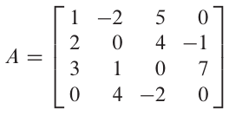then *A32* is obtained by crossing out row 3 and column 2,

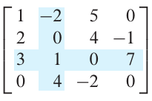so that

## Definition: Determinant

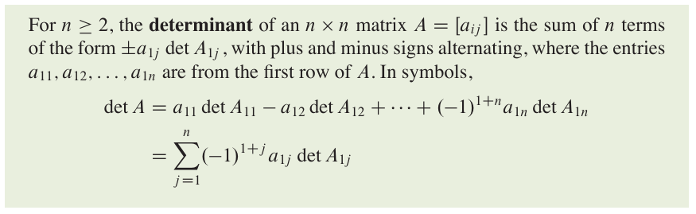

## Cofactor Expansion

Given *A* = [*aij*], the (*i, j*)-cofactor of *A* is the number *Cij* given by

*Cij =* (-1)*i+j* det*Aij*

Then

det *A* = *a*11*C11* + *a12C12* + … + *a1nC1n*

This formula is called a **cofactor expansion across the first row** of A.

### Theorem 1

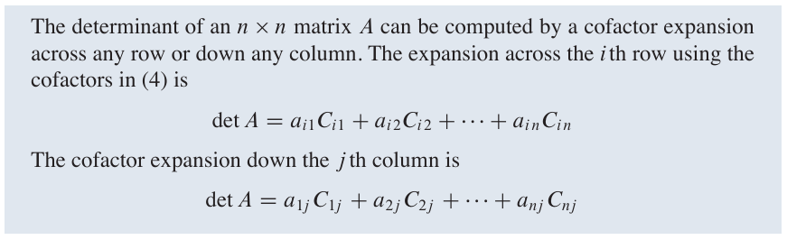

### Theorem 1

If *A* is a triangular matrix, then det *A* is the product of the entries on the main diagonal of *A*.

# 3.2 Properties of Determinants

## Row Operations

### Theorem 3

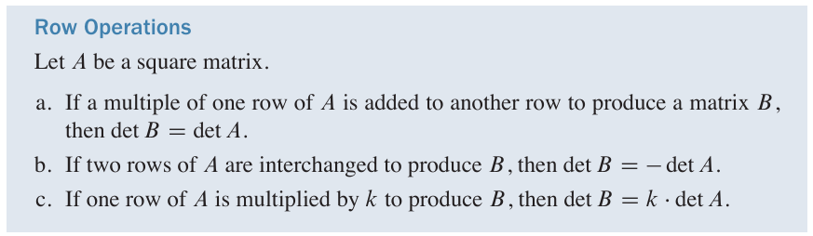

For a **square matrix** *A*,

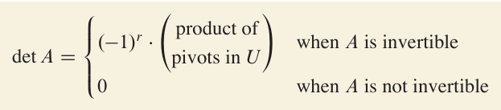

### Theorem 4

A **square** matrix *A* is invertible if and only if det *A ≠* 0.

## Column Operations

### Theorem 5

If *A* is an ***n* x *n***matrix, then det *AT =* det *A.*

### Theorem 6

If *A* and *B* are ***n* x *n***matrices, then det *AB =* (det *A*)(det *B*).

# 3.3 Cramer’s rule, Volume, and Linear Transformations

## Cramer’s rule

### Theorem 7

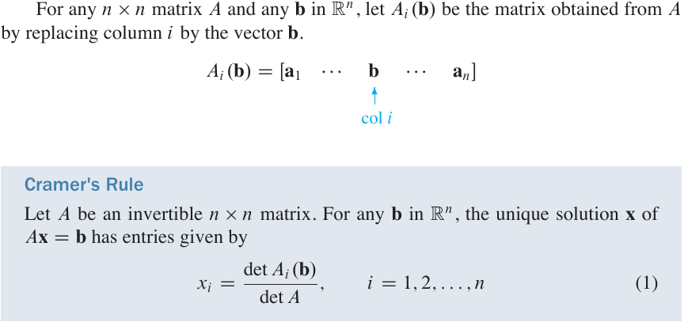

## A Formula for *A-1*

### Adjugate of *A,* classical adjoint of *A* (adj *A*)

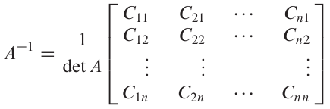上面方括号[ ]中的部分即为 adj *A*

### Theorem 8



## Determinants as Area or Volume

### Theorem 9

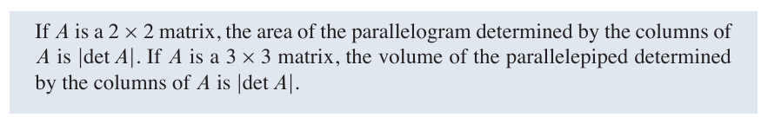

## Linear Transformations

### Theorem 10

